ASSIGNMENT 8 TREES
1)
#include <iostream>
using namespace std;

struct Node {
int data;
Node* left;
Node* right;

Node(int value) : data(value), left(nullptr), right(nullptr) {}
};

void preOrder(Node* root) {
if (root == nullptr) return;
cout << root->data << " ";
preOrder(root->left);
preOrder(root->right);
}

void inOrder(Node* root) {
if (root == nullptr) return;
inOrder(root->left);
cout << root->data << " ";
inOrder(root->right);
}

void postOrder(Node* root) {
if (root == nullptr) return;
postOrder(root->left);
postOrder(root->right);
cout << root->data << " ";
}

int main() {
Node* root = new Node(1);
root->left = new Node(2);
root->right = new Node(3);
root->left->left = new Node(4);
root->left->right = new Node(5);
root->right->left = new Node(6);
root->right->right = new Node(7);

cout << "Pre-order Traversal: ";
preOrder(root);
cout << endl;

cout << "In-order Traversal: ";
inOrder(root);
cout << endl;

cout << "Post-order Traversal: ";
postOrder(root);
cout << endl;

return 0;
}
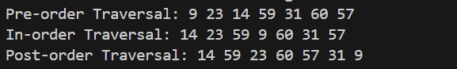

2)a)RECURSIVE
#include <iostream>
using namespace std;

struct TreeNode {
int val;
TreeNode* left;
TreeNode* right;
TreeNode(int x) : val(x), left(NULL), right(NULL) {}
};

void printTree(TreeNode* root) {
if (root != NULL) {
cout << root->val << " ";
printTree(root->left);
printTree(root->right);
}
}

TreeNode* searchRecursive(TreeNode* root, int key) {
if (root == NULL || root->val == key)
return root;

if (key < root->val)
return searchRecursive(root->left, key);

return searchRecursive(root->right, key);
}

int main() {
TreeNode* root = new TreeNode(20);
root->left = new TreeNode(10);
root->right = new TreeNode(30);
root->left->left = new TreeNode(5);
root->left->right = new TreeNode(15);
root->right->left = new TreeNode(25);
root->right->right = new TreeNode(35);
root->left->left->left = new TreeNode(3);
root->left->left->right = new TreeNode(7);
root->right->right->right = new TreeNode(40);

cout << "Tree (Pre-order traversal): ";
printTree(root);
cout << endl;

int searchKey1 = 15;
TreeNode* result1 = searchRecursive(root, searchKey1);
if (result1 != NULL)
cout << "Found: " << result1->val << endl;
else
cout << "Search failed! " << searchKey1 << " not found." << endl;

int searchKey2 = 100;
TreeNode* result2 = searchRecursive(root, searchKey2);
if (result2 != NULL)
cout << "Found: " << result2->val << endl;
else
cout << "Search failed! " << searchKey2 << " not found." << endl;

return 0;
}

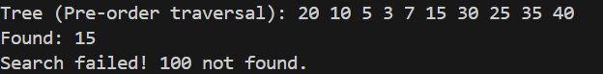
2)a)NON RECURSIVE
#include <iostream>
using namespace std;

struct TreeNode {
int val;
TreeNode* left;
TreeNode* right;
TreeNode(int x) : val(x), left(NULL), right(NULL) {}
};

void printTree(TreeNode* root) {
if (root != NULL) {
cout << root->val << " ";
printTree(root->left);
printTree(root->right);
}
}

TreeNode* searchNonRecursive(TreeNode* root, int key) {
while (root != NULL) {
if (root->val == key)
return root;

if (key < root->val)
root = root->left;
else
root = root->right;
}
return NULL;
}

int main() {
// Corrected BST construction
TreeNode* root = new TreeNode(23);
root->left = new TreeNode(10);
root->right = new TreeNode(36);
root->left->left = new TreeNode(5);
root->left->right = new TreeNode(19);
root->right->left = new TreeNode(30);
root->right->right = new TreeNode(65);
root->left->left->left = new TreeNode(3);
root->left->left->right = new TreeNode(8);

cout << "Tree (Pre-order traversal): ";
printTree(root);
cout << endl;

int searchKey1 = 10;
TreeNode* result1 = searchNonRecursive(root, searchKey1);
if (result1 != NULL)
cout << "Found: " << result1->val << endl;
else
cout << "Search failed! " << searchKey1 << " not found." << endl;

int searchKey2 = 20;
TreeNode* result2 = searchNonRecursive(root, searchKey2);
if (result2 != NULL)
cout << "Found: " << result2->val << endl;
else
cout << "Search failed! " << searchKey2 << " not found." << endl;

return 0;
}
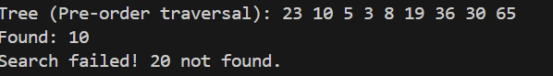
2)b,c)
#include <iostream>
using namespace std;

struct TreeNode {
int val;
TreeNode* left;
TreeNode* right;
TreeNode(int x) : val(x), left(NULL), right(NULL) {}
};

TreeNode* findMin(TreeNode* root) {
while (root != NULL && root->left != NULL) {
root = root->left;
}
return root;
}

TreeNode* findMax(TreeNode* root) {
while (root != NULL && root->right != NULL) {
root = root->right;
}
return root;
}

int main() {
// Constructing a sample BST
TreeNode* root = new TreeNode(23);
root->left = new TreeNode(10);
root->right = new TreeNode(36);
root->left->left = new TreeNode(5);
root->left->right = new TreeNode(19);
root->right->left = new TreeNode(30);
root->right->right = new TreeNode(65);
root->left->left->left = new TreeNode(3);
root->left->left->right = new TreeNode(8);

int choice;
cout << "Enter 1 to find Minimum element, or 2 to find Maximum element: ";
cin >> choice;

if (choice == 1) {
TreeNode* minNode = findMin(root);
if (minNode != NULL) {
cout << "Minimum element in the BST is: " << minNode->val << endl;
} else {
cout << "BST is empty!" << endl;
}
}
else if (choice == 2) {
TreeNode* maxNode = findMax(root);
if (maxNode != NULL) {
cout << "Maximum element in the BST is: " << maxNode->val << endl;
} else {
cout << "BST is empty!" << endl;
}
}
else {
cout << "Invalid choice!" << endl;
}

return 0;
}

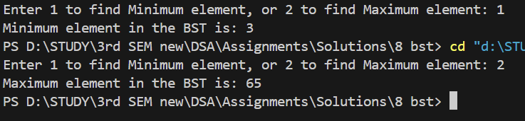

2)d,e)
#include <iostream>
using namespace std;

struct TreeNode {
int val;
TreeNode* left;
TreeNode* right;
TreeNode(int x) : val(x), left(NULL), right(NULL) {}
};

TreeNode* findMin(TreeNode* root) {
while (root != NULL && root->left != NULL) {
root = root->left;
}
return root;
}

TreeNode* findMax(TreeNode* root) {
while (root != NULL && root->right != NULL) {
root = root->right;
}
return root;
}

TreeNode* inorderSuccessor(TreeNode* root, TreeNode* node) {
if (node->right != NULL) {
return findMin(node->right);
}

TreeNode* successor = NULL;
while (root != NULL) {
if (node->val < root->val) {
successor = root;
root = root->left;
} else if (node->val > root->val) {
root = root->right;
} else {
break;
}
}
return successor;
}

TreeNode* inorderPredecessor(TreeNode* root, TreeNode* node) {
if (node->left != NULL) {
return findMax(node->left);
}

TreeNode* predecessor = NULL;
while (root != NULL) {
if (node->val < root->val) {
root = root->right;
} else if (node->val > root->val) {
predecessor = root;
root = root->left;
} else {
break;
}
}
return predecessor;
}

void printTree(TreeNode* root) {
if (root != NULL) {
cout << root->val << " ";
printTree(root->left);
printTree(root->right);
}
}

int main() {
TreeNode* root = new TreeNode(23);
root->left = new TreeNode(10);
root->right = new TreeNode(36);
root->left->left = new TreeNode(5);
root->left->right = new TreeNode(19);
root->right->left = new TreeNode(30);
root->right->right = new TreeNode(65);
root->left->left->left = new TreeNode(3);
root->left->left->right = new TreeNode(8);

cout << "Tree (Pre-order traversal): ";
printTree(root);
cout << endl;

int choice, nodeVal;
cout << "Enter 1 to find In-order Successor, or 2 to find In-order Predecessor: ";
cin >> choice;

cout << "Enter the node value to search for successor or predecessor: ";
cin >> nodeVal;

TreeNode* node = root;
while (node != NULL && node->val != nodeVal) {
if (nodeVal < node->val) {
node = node->left;
} else {
node = node->right;
}
}

if (node == NULL) {
cout << "Node not found in the tree!" << endl;
return 0;
}

if (choice == 1) {
TreeNode* successor = inorderSuccessor(root, node);
if (successor != NULL) {
cout << "In-order Successor of " << nodeVal << " is: " << successor->val << endl;
} else {
cout << "In-order Successor not found!" << endl;
}
}
else if (choice == 2) {
TreeNode* predecessor = inorderPredecessor(root, node);
if (predecessor != NULL) {
cout << "In-order Predecessor of " << nodeVal << " is: " << predecessor->val << endl;
} else {
cout << "In-order Predecessor not found!" << endl;
}
}
else {
cout << "Invalid choice!" << endl;
}

return 0;
}
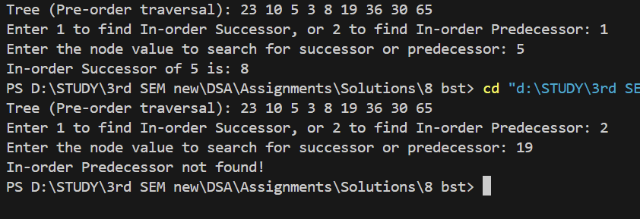

3)
#include <iostream>
using namespace std;

struct Node {
int data;
Node* left;
Node* right;

Node(int value) : data(value), left(nullptr), right(nullptr) {}
};

Node* findMin(Node* root) {
while (root && root->left != nullptr) {
root = root->left;
}
return root;
}

Node* insert(Node* root, int value) {
if (root == nullptr) {
return new Node(value);
}

if (value < root->data) {
root->left = insert(root->left, value);
} else if (value > root->data) {
root->right = insert(root->right, value);
}
return root;
}

Node* deleteNode(Node* root, int key) {
if (root == nullptr) return root;

if (key < root->data) {
root->left = deleteNode(root->left, key);
} else if (key > root->data) {
root->right = deleteNode(root->right, key);
} else {
if (root->left == nullptr) {
Node* temp = root->right;
delete root;
return temp;
} else if (root->right == nullptr) {
Node* temp = root->left;
delete root;
return temp;
}

Node* temp = findMin(root->right);
root->data = temp->data;
root->right = deleteNode(root->right, temp->data);
}
return root;
}

int maxDepth(Node* root) {
if (root == nullptr) return 0;
int leftDepth = maxDepth(root->left);
int rightDepth = maxDepth(root->right);
return (leftDepth > rightDepth ? leftDepth : rightDepth) + 1;
}

int minDepth(Node* root) {
if (root == nullptr) return 0;
if (root->left == nullptr && root->right == nullptr) return 1;

if (root->left == nullptr) return minDepth(root->right) + 1;
if (root->right == nullptr) return minDepth(root->left) + 1;

return (minDepth(root->left) < minDepth(root->right) ? minDepth(root->left) : minDepth(root->right)) + 1;
}

void inorderTraversal(Node* root) {
if (root == nullptr)
return;
inorderTraversal(root->left);
cout << root->data << " ";
inorderTraversal(root->right);
}

void menu() {
cout << "Menu:\n";
cout << "1. Insert an element into the BST\n";
cout << "2. Delete an element from the BST\n";
cout << "3. Display the BST (In-order traversal)\n";
cout << "4. Find Maximum Depth of BST\n";
cout << "5. Find Minimum Depth of BST\n";
cout << "6. Exit\n";
}

int main() {
Node* root = nullptr;
int choice, value;

while (true) {
menu();
cout << "Enter your choice: ";
cin >> choice;

switch (choice) {
case 1:
cout << "Enter the value to insert: ";
cin >> value;
root = insert(root, value);
break;

case 2:
cout << "Enter the value to delete: ";
cin >> value;
root = deleteNode(root, value);
break;

case 3:
cout << "In-order Traversal: ";
inorderTraversal(root);
cout << endl;
break;

case 4:
cout << "Maximum Depth of BST: " << maxDepth(root) << endl;
break;

case 5:
cout << "Minimum Depth of BST: " << minDepth(root) << endl;
break;

case 6:
cout << "Exiting program...\n";
return 0;

default:
cout << "Invalid choice! Please try again.\n";
}
}

return 0;
}
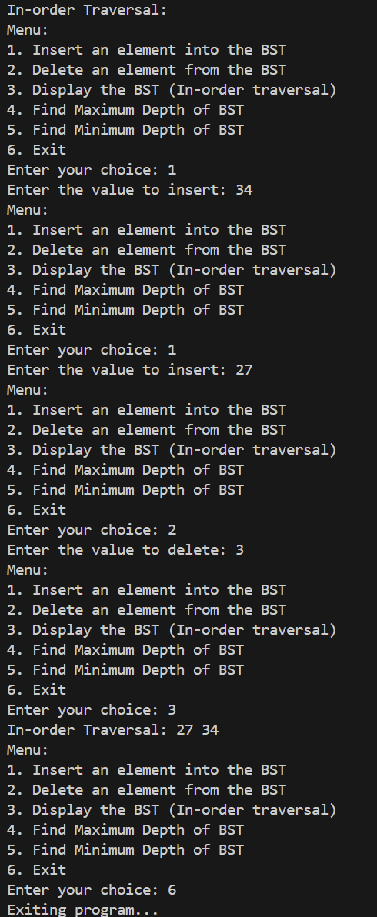
4)
#include <iostream>
using namespace std;

struct Node {
int data;
Node* left;
Node* right;

Node(int value) : data(value), left(nullptr), right(nullptr) {}
};

bool checkBST(Node* root, long long min, long long max) {
if (root == nullptr) {
return true;
}
if (root->data <= min || root->data >= max) {
return false;
}
return checkBST(root->left, min, root->data) &&
checkBST(root->right, root->data, max);
}

bool isBST(Node* root) {
return checkBST(root, -2147483648, 2147483647);
}

void inorderTraversal(Node* root) {
if (root == nullptr) {
return;
}
inorderTraversal(root->left);
cout << root->data << " ";
inorderTraversal(root->right);
}

int main() {
Node* root = new Node(10);
root->left = new Node(5);
root->right = new Node(15);
root->left->left = new Node(2);
root->left->right = new Node(7);
root->right->left = new Node(12);
root->right->right = new Node(20);

cout << "In-order Traversal of the Tree: ";
inorderTraversal(root);
cout << endl;

if (isBST(root)) {
cout << "The tree is a Binary Search Tree (BST)." << endl;
} else {
cout << "The tree is not a Binary Search Tree (BST)." << endl;
}

return 0;
}
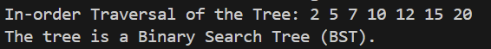
5) #include<iostream>
using namespace std;

class Heap {
private:
int *arr;
int capacity;
int count;

int parent(int i) {
if (i <= 0 || i >= count) {
return -1;
}
return (i - 1) / 2;
}

int leftChild(int i) {
int left = 2 * i + 1;
if (left >= count) {
return -1;
}
return left;
}

int rightChild(int i) {
int right = 2 * i + 2;
if (right >= count) {
return -1;
}
return right;
}

void resizeHeap() {
capacity = capacity * 2;
int *newArray = new int[capacity];
for (int i = 0; i < count; i++) {
newArray[i] = arr[i];
}
delete[] arr;
arr = newArray;
}

void percolateDown(int i) {
int left = leftChild(i);
int right = rightChild(i);
int max;
if (left != -1 && arr[left] > arr[i]) {
max = left;
} else {
max = i;
}
if (right != -1 && arr[right] > arr[max]) {
max = right;
}
if (max != i) {
swap(arr[max], arr[i]);
percolateDown(max);
}
}

public:
Heap(int capacity = 10) {
this->capacity = capacity;
count = 0;
arr = new int[capacity];
}

int size() {
return count;
}

bool isEmpty() {
return (count == 0);
}

int getMax() {
if (count == 0) {
return -1;
}
return arr[0];
}

void insert(int data) {
if (count == capacity) {
resizeHeap();
}
arr[count] = data;
int i = count;
count++;
int par = parent(i);
while (i != 0 && arr[i] > arr[par]) {
swap(arr[i], arr[par]);
i = par;
par = parent(i);
}
}

int deleteMax() {
if (count == 0) {
return -1;
}
int data = arr[0];
arr[0] = arr[count - 1];
count--;
percolateDown(0);
return data;
}

void printHeap() {
if (count == 0) {
cout << "Heap is Empty!!!" << endl;
} else {
for (int i = 0; i < count; i++) {
cout << arr[i] << " ";
}
cout << endl;
}
}
};

void heapSort(Heap &h, int *sorted) {
int i = 0;
while (!h.isEmpty()) {
sorted[i] = h.deleteMax();
i++;
}
}

int main() {
Heap h(20);
h.insert(6);
h.insert(89);
h.insert(81);
h.insert(27);
h.insert(16);
h.insert(11);
h.insert(31);
h.insert(129);
h.insert(3);
cout << "Heap after insertions: ";
h.printHeap();

int size = h.size();
int *sorted = new int[size];
heapSort(h, sorted);

cout << "Sorted array after heap sort: ";
for (int i = 0; i < size; i++) {
cout << sorted[i] << " ";
}
cout << endl;

delete[] sorted;
return 0;
}

6)
#include<iostream>
using namespace std;

class Heap
{
private:
int *arr;
int capacity;
int count;

int parent(int i)
{
if(i <= 0 || i >= count)
{
return -1;
}
return (i - 1) / 2;
}

int leftChild(int i)
{
int left = 2 * i + 1;
if(left < 0 || left >= count)
{
return -1;
}
return left;
}

int rightChild(int i)
{
int right = 2 * i + 2;
if(right < 0 || right >= count)
{
return -1;
}
return right;
}

void resizeHeap()
{
capacity = capacity * 2;
int *newArray = new int[capacity];
for(int i = 0; i < count; i++)
{
newArray[i] = arr[i];
}
delete[] arr;
arr = newArray;
}

void percolateDown(int i)
{
int left = leftChild(i);
int right = rightChild(i);
int max = i;
if(left != -1 && arr[left] > arr[max])
{
max = left;
}
if(right != -1 && arr[right] > arr[max])
{
max = right;
}
if(max != i)
{
swap(arr[i], arr[max]);
percolateDown(max);
}
}

public:
Heap(int capacity = 10)
{
this->capacity = capacity;
count = 0;
arr = new int[capacity];
}

int size()
{
return count;
}

bool isEmpty()
{
return (count == 0);
}

int getMax()
{
if(count == 0)
{
return -1;
}
return arr[0];
}

void insert(int data)
{
if(count == capacity)
{
resizeHeap();
}
arr[count] = data;
int i = count;
count++;
int par = parent(i);

while(i != 0 && arr[i] > arr[par])
{
swap(arr[i], arr[par]);
i = par;
par = parent(i);
}
}

int deleteMax()
{
if(count == 0)
{
cout << "Priority queue is empty!" << endl;
return -1;
}
int max = arr[0];
arr[0] = arr[count - 1];
count--;
percolateDown(0);
return max;
}

void printHeap()
{
if(count == 0)
{
cout << "Heap is Empty!" << endl;
return;
}
cout << "Heap elements: ";
for(int i = 0; i < count; i++)
{
cout << arr[i] << " ";
}
cout << endl;
}

~Heap()
{
delete[] arr;
}
};

int main()
{
Heap pq(20);

pq.insert(10);
pq.insert(3);
pq.insert(8);
pq.insert(7);
pq.insert(19);
pq.insert(16);
pq.insert(1);
pq.insert(12);
pq.insert(31);

cout << "Priority Queue elements after insertions: ";
pq.printHeap();

cout << "Extracted max: " << pq.deleteMax() << endl;

cout << "Current max after extraction: " << pq.getMax() << endl;

cout << "Priority Queue elements after extraction: ";
pq.printHeap();

return 0;
}

